Add cover Add comment

**Using 10 Year Notes In HTF Analysis**

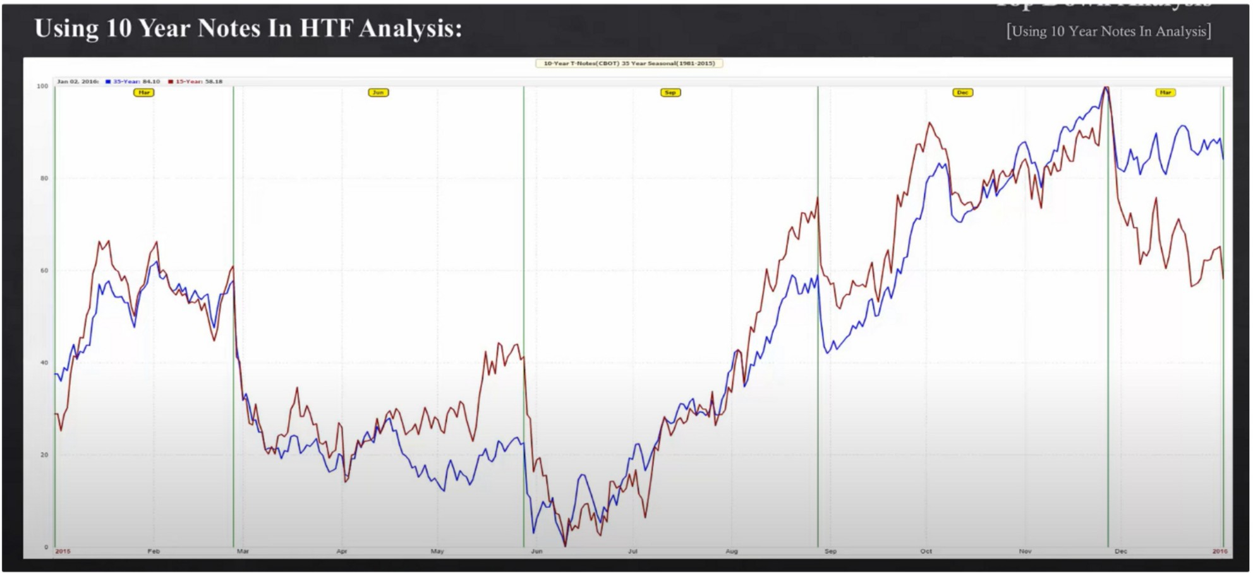

Seasonal tendency 1O year notes

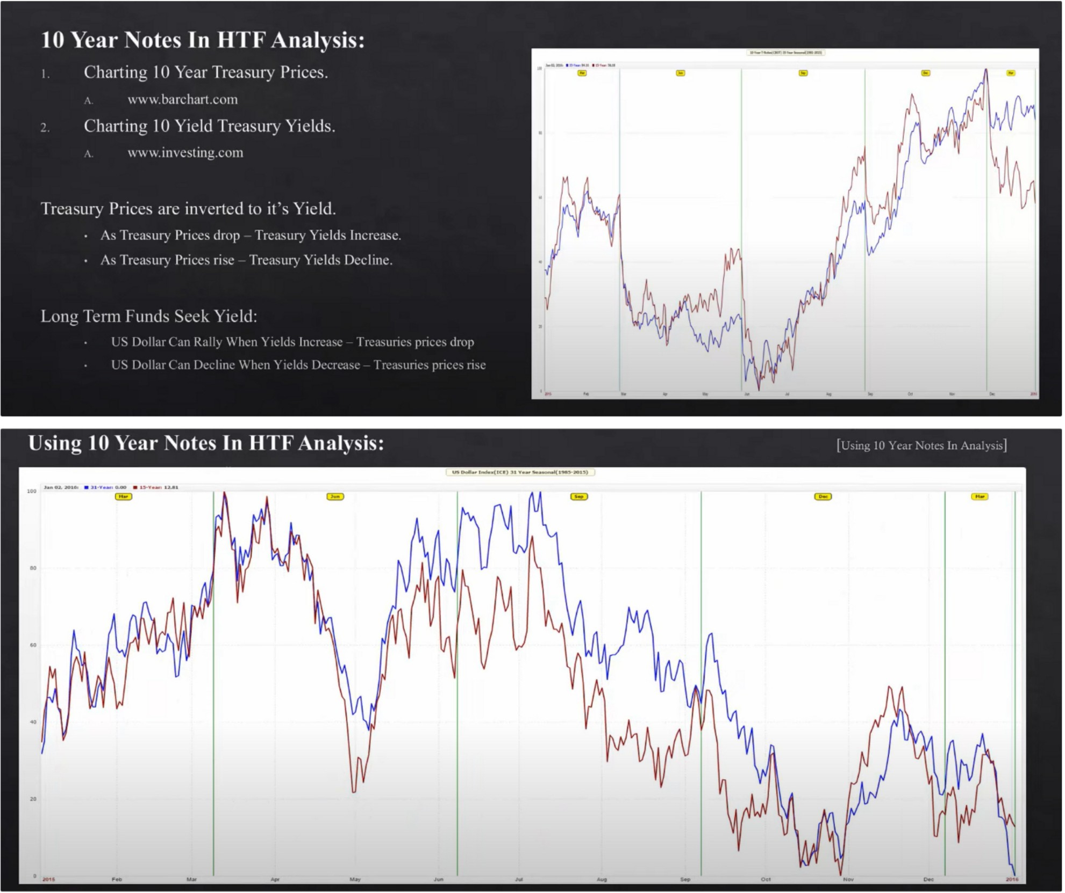

Seasonal tendency dollar

The primary 2 tendencies that are in alignment with the 1O year notes, bearish tone for dollar mid june to july. And some rallying for the dollar beginning of the year into march.

There is a seasonal tendency for dollar to decline march into may, but that would have to be in bearish markets and in bullish markets you could expect to see november be a buy, may be a buy and january be a buy for dollar index. And the sells come in at march, june july and 1 in september

If the the interest rates are dropping yield trades will avoid the dollar index, because if the interest rates are dropping thats not going to signal to buy dollar based assets.

The note and dollar are inversely correlated and give us a good thing to work with in seeing quarterly market shifts

If the dollar and 1O year note move in tendum so they move the same, that means were going to be in a large consolidation, we look to see previous highs and previous lows to be violated to trade back to the middle of the range

t \1111: lll'ltar '\01t, In **1111** \nah"'

' \- v¥V

I

\._

- **iJll1J1l!!] nlllldll11,d1lll!!d1lu1l11ll1l.lll lll1Jlll111.1. 1.. J1J!.Jllll•ll"lll•lu1\!!hl,1 1.. 11lhh1!!JII.IUI.** . _

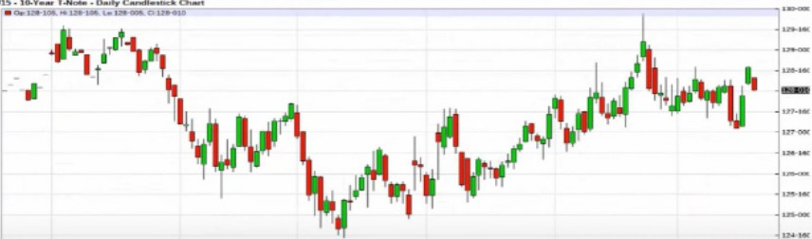

\n.1h\l,

§**.,,h!!!!,•.......11••111.1l'1!1lll1ll11,lllllll!!!lll,1i11111l111111IIJ!IIIIIIN m..,l!!!l•hllimlllllll1!!!1.1. ,,.1111,**:

l "Ill! 10 'll,tr '\01 , In **1111**

1 ,1111: IO'll.ir '\oh, In lilt \11ah'I,

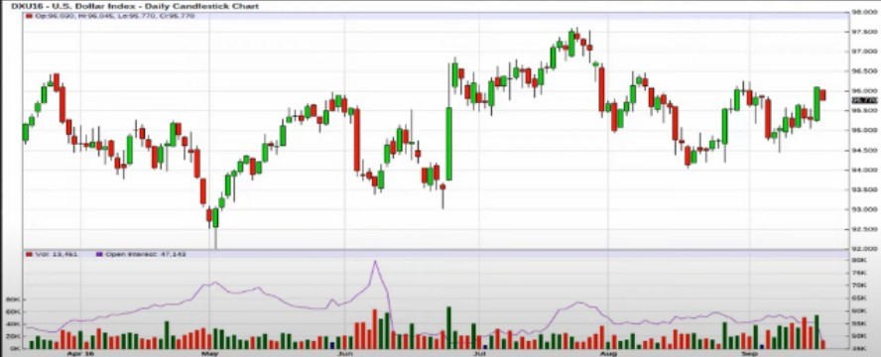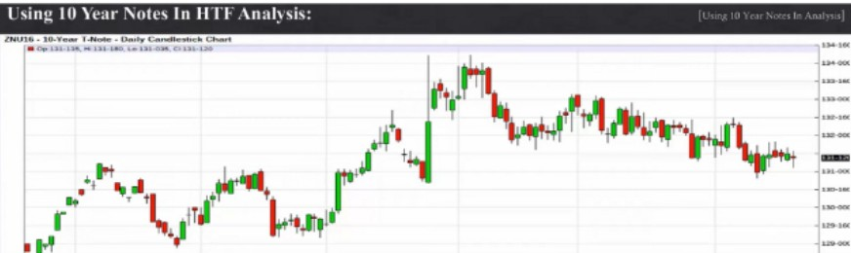

,, ....., .. .._

**'"·'!!! •........,,111111w111.. 111nU.l.ili!!!humhl11u,l11,IJ!lll,l11.1..u..11w111u111.hn11illkw11111111,.. ,** .i[

Again moving in tendum, so this means the market will be going into a large consolidation When this occurs, it means theres long term indecisiveness because both move in tendum. The

likelyhood of a continued trade direction for either one is highly unlikely, so we focus on stop raid or IPDA data range on both treasury and dollar index. For foreign currencies this means theyll go into a long term consolidation as well.

If we see the treasury move in the direction of the seasonal tendency and dollar also moves in the direction of his seasonal tendency then we have a strong probability of a long term trend. And thats where the large funds place there money, market will go in 1 direction for several months

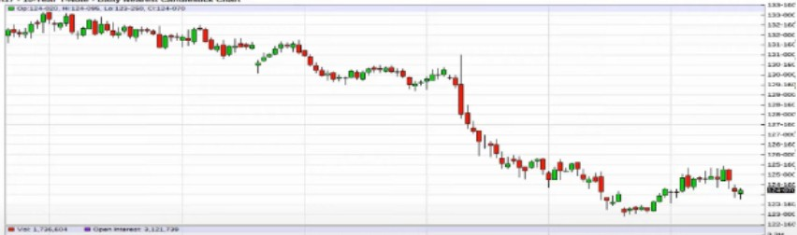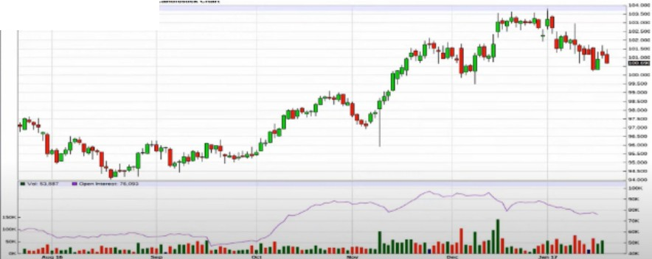

-..... ..-

So either the treasury moves in its seasonal tendency or it moves in tendum with the dollar and that

means were going to see a large consolidation

When are you looking for a trade thats going to be explosive in trending? When the 1O year treasury note is in effect and you see it happening and its supported with the contrarian price action on the dollar, if not and they move in a tendum then well focus on short term moves and will be low probability for long term trades. When its trending its high probability.

Also if we see the absence of the seasonal tendency of for example the strongest seasonal tendency buy signal around june july, then were going to be focusing on where the highs form in the 1O year treasury to get ourselves in sync with the opposite scope. So when a buy is the seasonal tendency of june july for 1O year T doesnt mean that that is the case because the markets arent always doing the same thing all the time, then we can focus primarily on bearish 1O year T trades which would give us the november high

Arjo I Twitter, lnstagram I Linktree

Linktree. Make your link do more.

, https://t.co/HhmmTN1fUI

JavaScript is not available.

W https://twitter.com/arjoio